I have read the Warrnambool City Council Event Planning Guide and agree with Warrnambool City Council’s mandatory conditions.
EVENT WASTE MANAGEMENT TEMPLATE
Part 1: Event Details & Event Contact Information

Name of Event
Name of Organisation
Date of Event
Anticipated Crowd Size
WCC Events Contact | Lauren Edney, Jack Whitehead, Chloe Jewell
Part 2A: Event Waste and Recycling Volumes

Applicants are required to assess the type and volume of waste, recyclables and / or FOGO generated during the general activities of the events in the following table. (ie: non stallholder)
(No general event waste - go to Part 2B)

GENERAL EVENT WASTE
Description of Activity/Product | Waste, Recyclable, FOGO Expected | Description of Material | Quantity Expected | Comments
Eg: Water for competitors | Water in cups | Paper cups | 500 | Cups are made from 100% paper, so can be recycled or composted.
Eg: Candles | Candles | Paper hand protector | 200 | Candles are waste or can be taken home & reused. Paper can be recycled
Part 2B: stall holder Waste and Recycling Volumes

Applicants are required to assess the type and volume of waste, recyclables and / or FOGO generated during the event by each stallholder in the following table. Add rows this table for each additional stall holder.
(No stalls - go to Part 3.)

FRONT OF HOUSE
Stall Name & Description | Waste, Recyclable, FOGO Expected | Description of Material | Quantity Expected | Comments  Supplier web link - serving material product proposed.
Eg: BBQ Stall | Sausage in bread | Paper Serviettes | 1000 | Tomato sauce will be available in communal squeeze bottles
Eg: BBQ Stall | Can of drink | Aluminium can | 950 | Paper straws will only be available on request.
Eg: Pizza Stall | Individual pizza | Pizza boxes | 500 | Carboard pizza boxes for takeaway only

BACK OF HOUSE
Stall Name & Description | Waste, Recyclable, FOGO Expected | Description of Material | Quantity Expected | Comments
Eg: BBQ Stall | Cardboard boxes | Boxes containing sausages | 20
Eg: BBQ Stall | Plastic bags | Bread bags | 100 | Bread bags will be kept separate and recycled through the RedCycle program.
Eg: Pizza Stall | Vegetable scraps | Onion peels, vegetable skins | 5kg | Will be removed from site by stallholder for FOGO
Part 3: waste, recycling, FOGO bins & skips

Use the following tables to estimate the number of bins required for your event.
Please note, this is for event patron waste only and does not allow for back of house waste generated by stall holders.
Bin Estimate Calculator works on the assumption of 1 litre of waste and 1 litre of recycling is generated per person per meal.
Fill in the blue cells to calculate number of bins required:

Please consider these points before finalising your bin requirements
Serving alcohol at your event?
- Reusable cups & glasses are the best option.
- If not using reusables for alcohol, extra recycling bins will be required.
- If the forecast is warm or hot & alcohol is being served, even more recycling bins are required.
Back of house requirements for stallholders and food preparation.
- Optimally this will be dealt with by the stallholders themselves ie: they take it away with them.
- Stallholders should not use the public place bins as this uses too much bin space leaving no room..
- Back of house bins or skips are best provided for stallholders away from the main part of the event
- Ensure stallholders know which receptacle for which waste stream.
- A cardboard cage or skip is useful for keeping this recycling stream clean and freeing up space in the other streams.
- Hiring of a mechanical bin lifter when using skips to manage waste ensures that OH&S requirements of emptying bins is met

ORDERED No. OF BINS FRONT OF HOUSE
(Use bin estimate calculator above)
No. of 240 litre general waste bins
No. of 240 litre bottle & can recycling bins
No. of 240 litre FOGO bins
ORDERED No. OF BINS/SKIPS BACK OF HOUSE
No. of 240 litre general waste bins
No. of 240 litre bottle & can recycling bins
No. of 240 litre FOGO bins
No. of general waste skips
No. of bottle & can recycling skips
No. of FOGO skips
Cardboard cage
Mechanical bin lifter
DO YOU REQUIRE SIGNS & BIN DRESSES FOR BIN STATIONS (Please circle)
No. of Bin station signs | YES NO
No. of red (waste) bin dresses | YES NO
No. of yellow (recycling) bin dresses | YES NO
No. of green (FOGO) bin dresses | YES NO
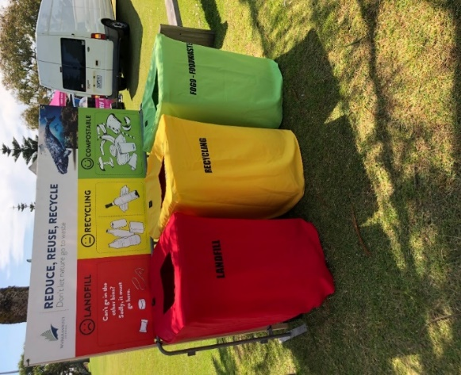

Part 4: waste minimisation initiatives

Are you implementing any of the following waste minimisation initiatives?
PROPOSED WASTE MINIMISATION ACTIVITIES (Please circle)
Use of WCC Water Fountains | YES NO | To book contact your WCC event officer or events@warrnambool.vic.gov.au
Wannon Water sponsorship  Make early contact | YES NO | https://www.wannonwater.com.au/stronger-communities.aspx
Set up wash stations for reusables | YES NO | Ensure compliance with Food Safety regs, refer Part 5, FAQs of WCC Events Planning Guide
Bin Monitors | YES NO

Please attach a site map to your waste management plan including the following:
Part 5: site map including bin locations and back of house waste area

- Location of Bin stations
- Location of food stalls, other stalls, stages, activities, competition or other attractions
- Back of house waste and recycling skips and bins
- Eating areas
- Main landforms, buildings & toilets
- Public entrances and exits
Part 6: contact details, checklist and conditions

ON SITE EVENT CONTACT DETAILS (for delivery of bin station signs and bin dresses)
Name
Mobile
Email
CHECKLIST
Waste Management Plans will not be approved unless al below information is provided:
- Details of all stallholders’ front and back of house waste
- Web link to stallholders’ packaging supplier
- A site map
- Event contact details including on site contact
- Calculations of waste, recycling and FOGO bins required for the event
- Delivery site for Bin station materials
APPROVAL PROCESS
- This Waste Management Plan will be reviewed as part of the Event application process.
- The contact person may be called if additional information is required.
- Allow plenty of time prior to the event to allow for processing of the application.
- This completed plan must be submitted to the WCC Waste Management Officer and Event Coordinator at least 2 months prior to the event.

ADDITIONAL FEE CONDITION
At the conclusion of the event, excess rubbish and other equipment associated with the staging of your event are to be removed and the area left in a clean and tidy condition.
If Warrnambool City Council is required to undertake any re-instatement, additional cleaning, removal of rubbish or other materials, you may incur a charge to restore the area to its pre-event condition. See Section 5.1 of the Event Planning Guide for more information.
I HEREBY ACCEPT ALL CONDITIONS IN THIS DOCUMENT AND STATE THE INFORMATION PROVIDED IS TRUE AND CORRECT
Name

Signature
Date

