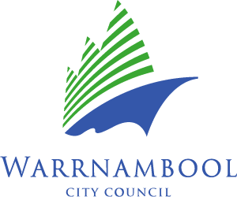**Warrnambool City Council**

**Event Resource Use Guidelines**

The Warrnambool City Council Events and Promotions Branch has a variety of event equipment and resources available free of charge for use at events in Warrnambool. The below guidelines relate to the use of the equipment.

**Guidelines**

In order to achieve the purpose of the guidelines, Council will:

1. Require that any resource loaned shall comply with the following conditions:
2. Short term, community based events delivered in Warrnambool.
3. The earliest that any resource shall be picked up will be 3 days prior to the event, and the resources shall be returned to Council the first business day after the event.
4. WCC does not deliver, pick up only. All resources shall be picked up and returned to the Barracks next to Flagstaff Hill, 89 Merri St.
5. Any event resources that are loaned shall be retuned in a clean workable condition. Pre and post inspection of the resources will be conducted. Any costs incurred due to breakages will be applied to the borrower.
6. It is the responsibility of the hirer to organise a suitable vehicle to transport the resources.

1. It is the responsibility of the hirer to load and unload resources into their vehicle at the users own risk.
2. Council reserves the right to refuse or alter any resource.
3. Transportation costs for resources and other costs associated with the resources are the responsibility of the organisation borrowing the resources.
4. Approvals for resources shall be limited to applications from local, community based organisations only. Event resources will not be loaned to commercial events or trade promotions, unless conducted by a community based or charitable organisation.
5. Bookings shall only be taken a maximum of 12 months in advance
6. Written applications, issue of permits and enforcement of the Guidelines shall be administered out by the Events and Promotion Service Manager.