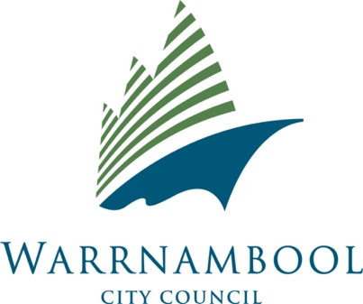

Short Stay Rental Accommodation

**Designated Contact Person advice & template letter**

**What is a Designated Contact person?**

It is a requirement under clause 11.3 (b) of the Warrnambool City Council Short Stay Accommodation Local Law that the owner of a Short Stay Accommodation must provide adjoining neighbours on all boundaries the contact details of the designated person. This also includes neighbouring properties directly across from the Short Stay Accommodation.

Council has prepared a sample template letter (over page) that owners of registered Short Stay Accommodation may wish to use. This template letter allows you to add specific information relating to the designated contact for your property.

A designated contact may include:

* A security company
* A real estate agent or managing agent
* An individual (including the property owner)

This designated contact person must respond within two hours to any contact made. A response may include any action taken to deal with the issues raised. The designated contact person is not expected to be involved with matters that would require Police intervention, such as aggressive or threatening behaviour. Please call Victoria Police on 000 in these events. In the event that Council receives a complaint, a Council officer may request information on the action taken to deal with any issues reported to the designated contact.

**Privacy Statement**

In accordance with Council’s commitment to privacy, only details of the designated contact person (as nominated on the application form) will be made available to a neighbour.

Individuals may access their personal information held by the Council and request corrections if necessary by contacting Council in writing by email to [contact@warrnambool.com.au](mailto:contact@warrnambool.com.au) or mail to Warrnambool City Council, PO Box 198, 25 Liebig Street, WARRNAMBOOL VIC 3280.

**Short Stay Accommodation – Letter to Neighbours**

<Enter Date>

Dear Neighbour,

We have a Short Stay Accommodation property that is registered with the Warrnambool City Council, under the Short Stay Accommodation Local Law. The property is located at:

<Enter the property address here>

The designated contact person for the property is:

|  |  |
| --- | --- |
| **Name** | **Contact Number** |
| <Enter the contact name here> | <Enter the contact number here> |

The above person can be contacted in the event of a disturbance to the peace or amenity arising from the property. The designated contact person is not expected to be involved with matters that would require Police intervention, such as aggressive or threatening behaviour. Please call Victoria Police on 000 in these events.

The designated contact person will discuss the expected behaviours with the occupants and ask for their compliance. If the poor behaviour continues then please contact Council on:

**(03) 5559 4800 or 1300 003 280**

Please be aware that only the designated contact information is public information.