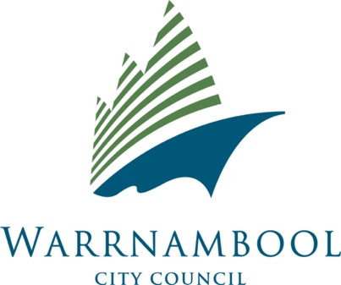

Short Stay Accommodation

**Important Visitor Information**

Welcome to South West Victoria, we sincerely hope you enjoy your stay. This property is registered under the Warrnambool City Council Short Stay Accommodation Local Law. Guests of this property must ensure they read and follow the requirements of the Code of Conduct during their stay.

**The Code of Conduct requires guests to:**

* Behave responsibly during your stay. Loud singing, yelling, screaming, cheering, and aggressive behaviour is NOT acceptable and may result in the early termination of your stay if a complaint is received by Council
* No additional accommodation is permitted on site such as tents, caravans, campervans
* Do not use outdoor areas for activity between 11.00 pm to 7.00 am
* Place all waste into the bins provided prior to leaving

Park all vehicles within the property boundary. Occupant and visitor cars cannot be parked out on the street or on nature strip areas.

**Additionally, the Owner of this property requires you to:**

* Add your text here as required
* Add your text here as required
* Add your text here as required
* Add your text here as required

Please be mindful while enjoying your stay that surrounding neighbours live in this community and are entitled to peace and amenity in their residential area, thank you.

A serious breach of the Code of Conduct may result in the termination of your rental agreement and require you to immediately vacate the property.

Further information can be found at[**www.warrnambool.vic.gov.au**](http://www.warrnambool.vic.gov.au)and search for **“Short Stay Accommodation”.**