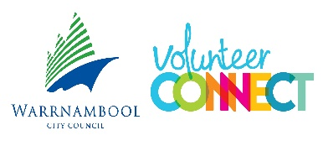
Warrnambool City Council Volunteer Reference Group

Expression of Interest Form

Volunteer Contact Details
Name: | Date:
Council Years of service: | Home/Office Phone:
Email: | Mobile:
Expression of Interest Questions
What current volunteer roles do you have with Council?

Why are you interested in joining the VRG?

How do you demonstrate the Council values when you volunteer?
What skills, experience, knowledge, and personal attributes do you have – that will support the purpose of the VRG?
VRG members will need to focus on achieving outcomes.
Please tell us about a time when you have helped deliver a goal to the benefit of your team.
Do you wish to provide relevant referees if you have had previous experience on consumer/volunteer committees?
Are you currently on any other Council consumer/volunteer committees?
Are you currently on any other public committees that may incur any Conflict of Interest?

Application and Selection Process
Volunteers who wish to express an interest in becoming a member of the Volunteer Reference Group (VRG) are invited to complete the Expression of Interest Form.

VRG Expression of Interest Forms are available through Volunteer Engagement Coordinators on program sites, or through Volunteer Connect.

Expression of Interest Forms can be returned in person, by mail, or by email to:
Volunteer Connect
Archie Graham Centre, 118 – 130 Timor Street, Warrnambool. VIC. 3280
volunteer@warrrnambool.vic.gov.au

All volunteer applicants for VRG will receive written notification of selection outcomes.

