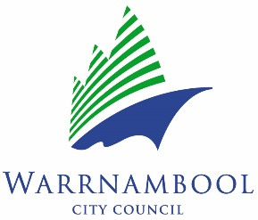

**Warrnambool Seniors Festival 2025  
Expression of Interest to Host an Event**

Details of events will be published in our Warrnambool Seniors Festival 2025 Program and on the Warrnambool City Council website and events will be promoted on social media where feasible.

Clubs, community groups and cultural organisations will be encouraged to add events to the online Victorian Seniors Festival Program.

(PLEASE WRITE IN BLOCK LETTERS)

Group/Organisation name:

ABN:

Organiser’s name:

Organiser’s telephone number:

Facebook PageTAG or URL:

Title of Event:

Date of Event:

Time of Event:

Venue for the Event:

Are bookings required? Is catering provided? Is there wheelchair access?

Yes Yes Yes

No No No

**Information that will be published for the public:**

Name of person to contact for bookings:

Phone number of person to contact for bookings:

Cost per person/or FREE:

Brief description of your event (what participants can expect on the day):

Please be sure to submit your Event Expression of Interest Form by **Friday 13 June** to: [agccustserv@warrnambool.vic.gov.au](mailto:agccustserv@warrnambool.vic.gov.au) or Archie Graham Community Centre Reception; 118-130 Timor St Warrnambool, VIC 3280