Great South Coast Regional Digital Strategy Briefing Pack

# Introduction to Digital Regions

A Digital/ Smart Region is a region that applies integrated digital technology, data and innovative practices to improve liveability, sustainability, collaboration and economic opportunities.

Successful digital regions do not just focus on digital technology per se, but also on developing the systems, processes and programs that support collaboration and innovation both within councils and throughout the community.

Digital transformation ultimately aims to provide digital solutions to real community problems. Thus, it is essential that the Great South Coast region recognise the unique context, needs and priorities of its region as well as its internal capability and capacity in the development of this Strategy.

# Digital Technology Opportunities

The adoption of digital technologies and organisational digital transformation provide many benefits internally within Councils and to their communities.

The following Council services and assets could especially benefit from digital transformation:

|  |  |
| --- | --- |
| * Economic Development * Building and Planning * Waste Management * Environment and Conservation | * Health and Safety * Parks and Open Space * Community Facilities and Participation * Arts |

# Great South Coast as a Digital Region

The City of Warrnambool and Shires of Moyne and Corangamite, through their Regional Digital Strategy, aim at particular outcomes:



### Enhanced Connectivity and Accessibility

Technology can be leveraged to increase equity in the community ensuring residents have access to council services, are connected to the internet, and have the digital skills to engage with other digital elements of the city.

### Efficiency Icon Vector Art, Icons, and Graphics for Free DownloadImproved Efficiencies

Digital adoption provides a council’s staff the tools and resources they need to be more effective in their role and deliver better services to the community. Digital solutions provide opportunities to automate Council services, increasing their speed and responsiveness.

### Data Management Icon Stock Vector (Royalty Free) 755109346Improved Data Management

Digital transformation creates better systems for gathering, sharing and storing data. This improved handling of data enables council to operate with greater intelligence and adopt data-driven decision making.

### 

### Employee engagement icon symbol on white Vector ImageBetter Citizen Collaboration and Engagement

Technology enables councils to deliver robust, user-friendly digital services and engage with their communities in new ways. Greater transparency from a council coupled with strong channels for engagement increase participation rates within the community and trust in the organisation.



### Improved Productivity

Improving digital frameworks and connectivity improves productivity across all sectors. Better technology enables autonomy in local businesses enabling greater production and yield, while also improving the responsiveness of Councils.

### News | Department of Infrastructure, Transport, Regional Development and Communications

### Safer Communities

Councils can leverage digital technologies to improve security and safety within their communities. Digital transformation opens up an abundance of opportunities leading to safer and smarter communities.

### Open hand with plant outline

### Reduce Environmental Footprint

Digital solutions help to mitigate a council’s contribution to global warming by reducing waste production, promoting renewable energy and reducing greenhouse gas emissions.

# Why a Digital Strategy?

Digital technology can and should be used across all operations and services of local government, benefitting councils, key stakeholders and the community. However, with such broad relevance and potential, it is essential that implementation of this technology is guided through strategy to promote:

* Coherent integration, rather than siloing, of new tools
* Effective inter-council coordination
* Long-term technological planning through clear objectives

Thus, the key to success in establishing quality digital infrastructure is to develop a holistic strategy that addresses the needs of a given region and accounts for the evolving nature of digital technology. The best practice principles below will guide Great South Coast region in its development of the Strategy and its overall digital transformation.

# Strategic Alignment

Coordination and alignment to the strategic context is crucial to ensuring funding, interoperability, successful implementation and on-going success in digital transformation.

### Internal Coordination will require:

* 1. Aligning digital strategy actions with Councils’ Community Plans
  2. Robust digital transformation governance to coordinate responsibility and accountability

### External Coordination will require:

* 1. Aligning strategy and policy with State and Federal objectives for funding and collaboration opportunities
  2. Key documents: Federal Digital Government Strategy, Victorian Government Digital Strategy, Great South Coast Regional Digital Plan

# Digital City/ Region Building Blocks

## Global Best Practice

Developed based on global best practice, the principles below will provide a framework for digital city/ region success. These principles will guide the development of Great South Coast Regional Strategy, ensuring action remains holistic and focussed.

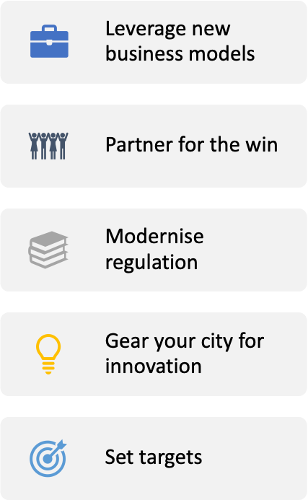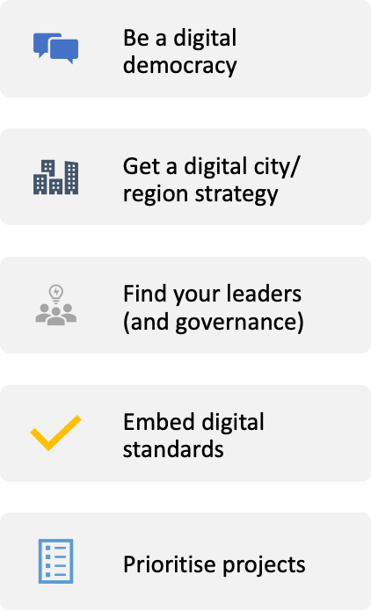

## Digital City/Region Risks

Like any investment and any technology, digital cities/regions can present some risks. These could include:

|  |  |
| --- | --- |
| * Increased cyber-security risk profile * Impacts on privacy * Smart tech without a clear ethical framework * Digital exclusion | * Low digital literacy * Digital misinformation * Disconnected digital systems |

However, with a clear Regional Digital Strategic Framework in place, the City of Warrnambool and Shires of Moyne and Corangamite can substantially mitigate these risks and achieve the manifold benefits for which these technologies clearly present opportunity.

# Glossary

|  |  |  |  |
| --- | --- | --- | --- |
| **Big Data** | The use of technology (especially sensors and networks) to collect, manage, analyse and utilise large volumes of data. | **Innovation ecosystem** | The network of people, institutions, programs, regulations, culture and resources that work to promote innovation |
| **Citizen-centric** | Approaching Council service delivery from the perspective of the community to ensure their needs and expectations are met. | **Liveability** | The general perceptions of the quality of life living in a particular area. Take into account accessibility, safety, inclusion, local services and the environment. |
| **Co-creation/ Co-Design** | Working with clients, communities and customers to design and create services/solutions that meet user expectations and needs. | **Local Services** | Public services provided by the local government (eg Parks, parking, planning, rubbish collection). |
| **Connectivity** | The breadth depth and quality of telecommunications and internet infrastructure, networks and services. | **Open Data** | Making data more accessible and useable to enhance transparency, innovation and community outcomes.  *Note* s*ensitive, confidential and private data will remain secure.* |
| **Co-working** | The mode of working where a mix of individuals, innovators and organisations work in the same physical location, sharing space, ideas, technology and motivation. | **Place Activation** | Integrating new and innovative enterprises and projects to attract and retain people to underutilised public spaces. |
| **Digital Democracy** | The use of digital technology to modernise democratic processes and institutions and facilitating participation in debate and decision-making. | **Red Tape** | Inefficient legislation, regulation or business processes that inhibit innovation and place undue cost on the economy. |
| **Digital Literacy** | The skills and capabilities to effectively and confidently use digital technology. | **Smart Technology** | Digital networks, sensors and systems that support the delivery of smart services and assets |
| **Entrepreneur** | A person who creates, innovates, invests and takes on risk aiming to commercially profit. | **Sustainability** | Balancing social, economic and environmental needs and priorities. |
| **Innovation** | Doing something different with the aim of improving processes and outcomes. | *Source: Delos Delta* | |