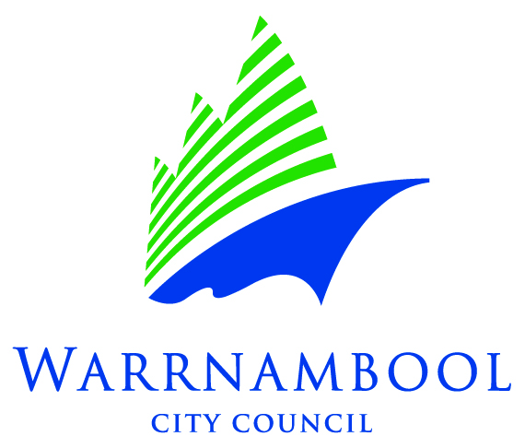

**Expression of Interest – Welcoming Space Mural**

The new Breton St Playground has been selected as a demonstration public art project as a part of the Playground Renewal program. Warrnambool City Council are seeking an artist or artists to create public art on an adjacent garage wall.

Expressions of interest are now being sought from experienced artists to create the mural. The project could be developed working in conjunction with members of the neighbourhood. to develop or implement the concept.

Applicants are required to include a concept, budget and proposed timeline for the project completion. A panel consisting of WCC officers from the Recreation and Culture team will assess the application. Applicants will be informed of the decision on or before May 31st, 2024. The panel’s decision will be final.

Applications will be assessed on;

* Project able to be completed within budget and an acceptable timeframe,
* Alignment with the principles in Council’s Public Art Policy,
* Artists experience and capacity to deliver the artwork to a high standard,
* Concept aligns with the brief.

**The Brief;**

The theme is ‘Welcoming Space’.

Artwork should appeal to preschool and primary aged children aged up to 12 years.

Design should be bright, fun and have positive themes.

The mural will be painted *only* with no attached objects.

The mural should meet the principals as outlined in Council’s public art policy. <https://www.warrnambool.vic.gov.au/policies>

As per the Policy commissioned works will be via an Art Commission Agreement, and relevant transfer of title documentation must be completed. On finalisation of the artwork it will be catalogued in the Public Art Register.

**Copyright**

Imagery used must be the intellectual property of the artist and not infringe upon another’s copyright. Copyright of the mural will remain with the artist.

**SUBMISSIONS DUE: 5pm, Friday the 17th of May, 2024**

|  |
| --- |
| Applicant details |
| Name: |
| Address: |
| Phone: |
| Email: |
| Website / Social Media Portfolio: |
| ABN: |

|  |
| --- |
| Artist statement |
| Please provide a summary of style and experience relevant to the project. |
| Max 200 words |

|  |
| --- |
| Mural Concept |
| Applicants should describe their concept and supply examples of similar work they have done previously, so as to give the assessing panel a clear idea of what the mural design will be. |
| Max 200 words |
| Selection criteria |
| Please note the following conditions of entry: |
| 1. Demonstrated capacity to deliver a mural. |
| 1. A folio of artwork examples similar to the proposed mural. |
| 1. Provision of a brief description of the mural plan, including materials. |
| 1. Inclusion of a brief written concept for the mural that links with the theme of ‘Welcoming Space’. |

|  |
| --- |
| Budget |
| A maximum budget of $7,500 is available for the project, inclusive of materials and artist fees.  Please provide the proposed budget breakdown for expenses related to the delivery of the mural, including materials (surface preparation, paint and graffiti-proof coat), design, project management and implementation. The wall is approximately 27 square metres (2.9 x 9m).  Council asserts that artists should be paid for their work and earn income from copyright and royalties. We consider the payment of artists for their work and project management costs to be integral to effective budgeting and planning, and we require information on artists’ payment to be available within funding applications. Artist fees should be in accordance with industry benchmarks. <https://code.visualarts.net.au/payment-rates/overview>  Scaffolding will be provided by Council if required (at no cost), and permits and safety requirements will be arranged in collaboration with the artist as required. |
|  |

|  |
| --- |
| Support material |
| Attach support material such as photographs, digital images of previous and/or recent murals, as well as any concepts for this mural. Support material should be clearly marked with the artist’s name and title of the artwork. Please also attached an artist’s CV. |
| List of supporting materials: |
| 1 |
| 2 |
| 3 |
| 4 |
| 5 |

**Section 3: Declaration by person/s making the submission**

* I/We agree to accept the selection committee’s decision as final.
* I/We declare this is my own work.
* I/We state that the above information is true and correct.

**NAME/S:**

**SIGNATURE/S:**

**DATE:**

**Submissions can be made:**

|  |  |  |
| --- | --- | --- |
| **By post:**  On or before 5pm,  Friday 17th May 2024  25 Liebig St  Warrnambool  Victoria 3280 | **By delivery:**  On or before 5pm,  Friday 17th May 2024  Warrnambool City Council  25 Liebig St  Warrnambool  Victoria 3280 | **By email:**  On or before 5pm, 17th May 2024, with the subject line *Breton St Playground public art* togcolliton@warrnambool.vic.gov.au |

For further information please contact Cultural Development Coordinator, Gareth Colliton, at [gcolliton@warrnambool.vic.gov.au](mailto:gcolliton@warrnambool.vic.gov.au)