COUNCIL ADVISORY COMMITTEE

EXPRESSION OF INTEREST

AS AN independent MEMBER
audit & risk committee
4 March 2025 – 28 February 2028

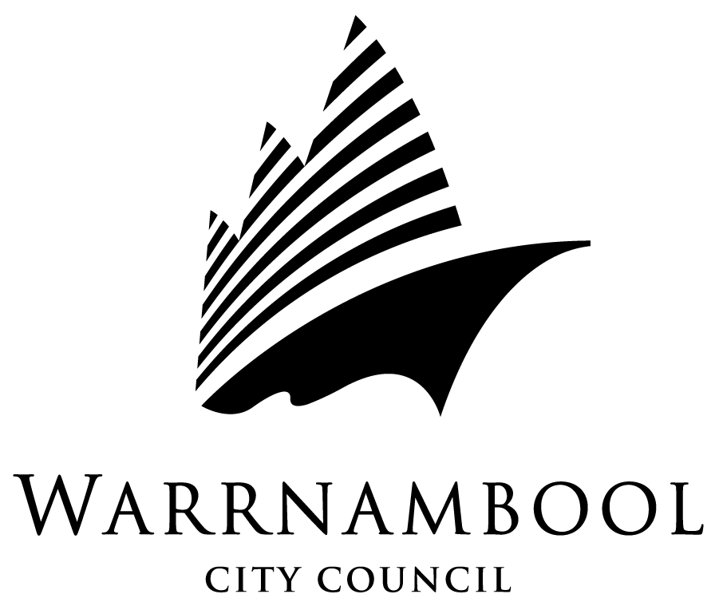

1. NAME:

ADDRESS:

PHONE:. (Home) (Business)

EMAIL ………………………………………………..

SKILL SET:

2. Current or previous experience in financial management, risk management, business skills and experience in audit processes and/or audit committees.

3. Special skills you believe you could offer the Audit & Risk Committee.

4. Any other relevant information you wish to provide.

5. Please list relevant qualifications.

(Please also attach any supporting information you may wish to submit)

6. REFEREES:

Please provide the names of two referees to support your Expression of Interest.

1. NAME:

ADDRESS:

PHONE: EMAIL

2. NAME:

ADDRESS:

PHONE: EMAIL

NOTE: Please provide a curriculum vitae with your application.

For further assistance or clarification contact John Brockway, Manager Financial Services on (03) 5559 4971.

Please mail or deliver your Expression of Interest to:

Mr John Brockway
Manager Financial Services
Warrnambool City Council
25 Liebig Street
(PO Box 198)
WARRNAMBOOL 3280
jbrockway@warrnambool.vic.gov.au

….to arrive at Warrnambool Civic Centre no later than 5pm 7th February 2025.

Your Expression of Interest will be treated on a confidential basis. In addition, Council will only give public information regarding the appointed Independent Members following further contact in each instance.

